Name: **ZOHAIB HASSAN SOOMRO**

RollNo#: **19SW42**

Subject: **DBS**

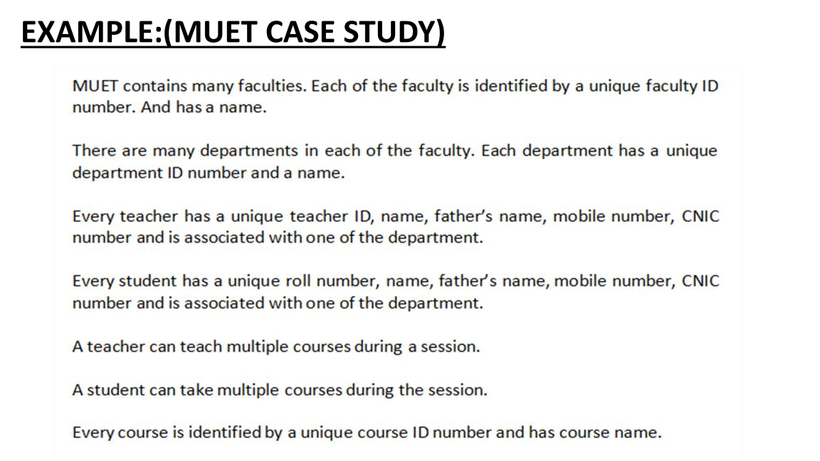

**Ans:**

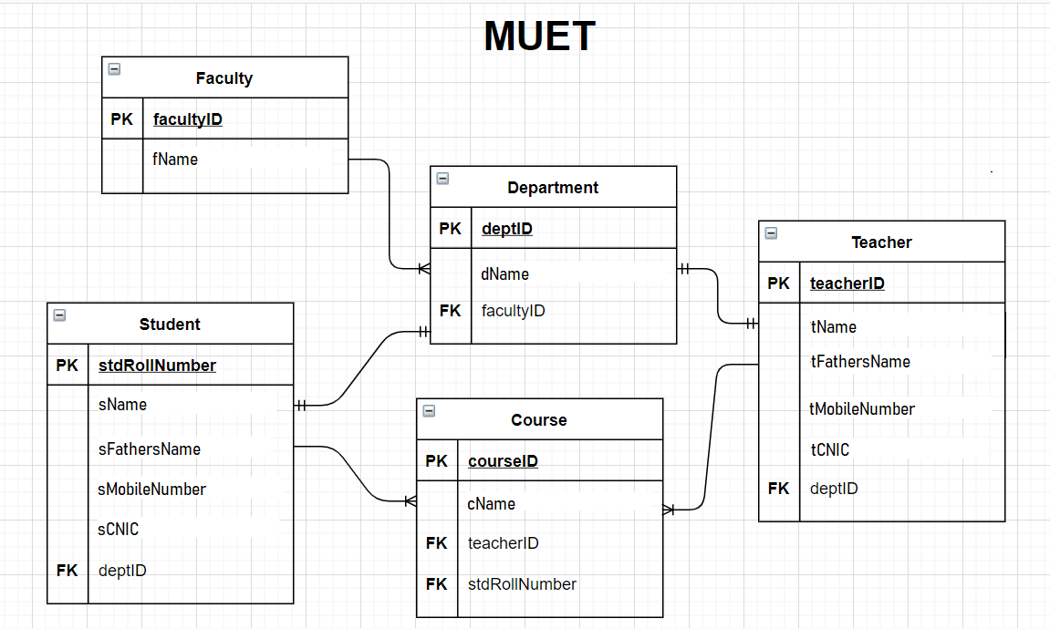

1. **convert the entitites into tables and attributes in columns of the table.**

**Below diagram shows that the tables are in normalized form**

**Perform** Combining Tables method on the tables shown in diagram

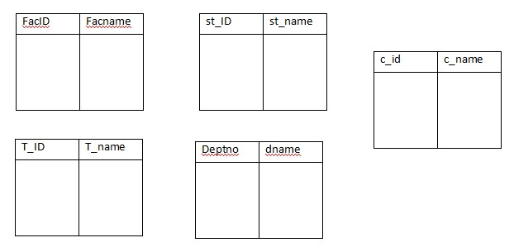

**Ans:**

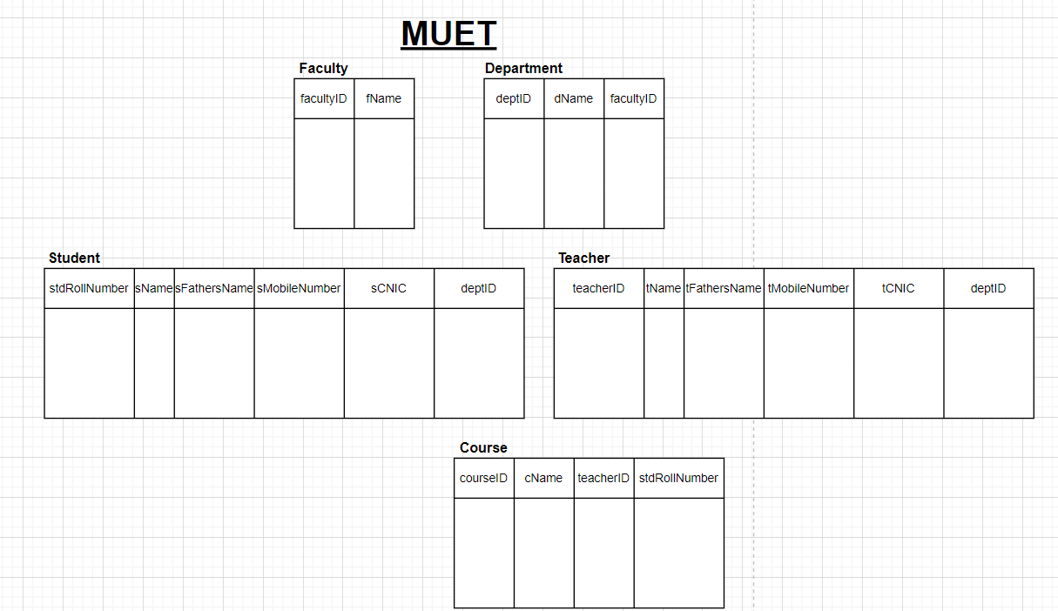

1. To convert it in denormalization, combine all the tables to make it a single table

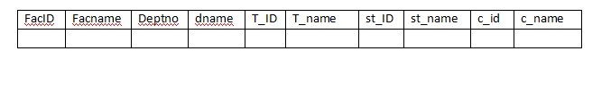

**Ans:**

